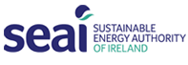
Better Energy Communities 2016 Request for Payment Form

MUST be completed by the Grantee
Name of Grantee:
Project Reference Number:
Project title:
This is an interim payment request | This is a final payment request
SEAI Grant approved: (€)
Amount of Grant requested :(€)
Estimated project completion date:
Estimated project completion by: %
Value of works to date: (€)
Please attach the following documentation to back up all reported expenditure related to this claim
- Completed Grant Claim Workbook
- Copies of all invoices
- Proof of payment (confirmation from supplier that invoice has been paid) and
- All relevant Bank statements.
Please confirm your bank details | Name of Bank
Please confirm your bank details | Account Name
Please confirm your bank details | Account Number
Please confirm your bank details | Sort Code
Please confirm your bank details | IBAN
Please confirm your bank details | BIC

We hereby apply for Grant Payment as detailed above. The amounts were incurred and paid for within the period of the Grant Agreement and are in accordance with the books and records of the Company. We declare that the information contained in this Request for Grant Payment is true, accurate and complete and all copies of invoices and proof of payment provided are a true copy.
Signed (Grantee Authorised Signatory):
Name (BLOCK CAPITALS):
Position:
Date:
Signed (Project Coordinator:
Name (BLOCK CAPITALS):
Date:

NB: Please sign and date the form above and upload to PEP. If you are unable to upload to PEP send by e-mail to BEC@seai.ie

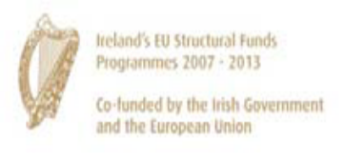 | 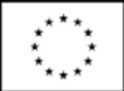 |  | The Sustainable Energy Authority of Ireland is financed by Ireland’s EU Structural Funds Programme cofounded by the Irish Government and the European Union

