Communities Programme 20__  Client Organisation Declaration | 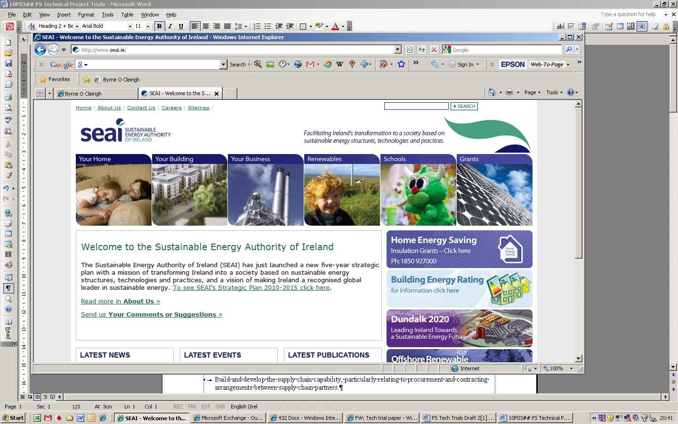

To be completed by the Client Organisation
Client Organisation Name
Project Reference Number
Project Title
Facility Address
List all locations where the energy savings have been achieved and credits are being assigned from.

Name of Participating Energy Supplier PES | Choose an item.
Are the Energy Credits from this project to be attributed to the PES noted above (please note if there is more than one PES involved in a project a separate form must be submitted for each PES detailing input into a project) | Choose an item.
Please confirm % of Energy Credit to be assigned to the Energy Supplier: *
Would this project have been completed without the input of the Participating Energy Supplier listed above | Choose an item.
Please explain why the Energy Suppliers contribution is deemed to be material to the project (please explain why you chose this Energy Supplier and what value they contributed and why it is deemed to be demonstrably material to the project. Please note credits may by rejected for a project if this section is not completed to allow for appropriate evaluation by SEAI)

Declaration of Client Organisation
- I hereby declare that the information provided in respect of this application is to the best of my knowledge correct. I am duly authorized to sign on behalf of the client organisation(s).
- I agree to allow SEAI or its delegated agent(s) to verify any of the information contained herein which is reasonably available
- I confirm that Energy Supplier indicated in this form has been involved in the execution of this project and has been material to the achievement of the claimed savings.
- I confirm that the Energy Supplier should be awarded the indicated energy savings from this project
Signature on behalf of the Client Organisation
Name (BLOCK CAPITALS)
Position
Date
Contact email

