The Support Scheme for Renewable Heat

Design Report -Guidance
(Tariff scheme)

Version 8, Dec 2021
Contents

Introduction 3
The Design Report 4
1. Details of Design Engineer* 4
1.1 Credentials of Design Engineer 4
1.2 Appointment and Commitment of Design Engineer 4
2. Executive summary (brief overview of the project) 4
Description of heat use and heating systems (old and new) 4
3. Description of Scope of Works 5
3.1 Scope of Works 5
3.2 Flues 6
3.3 Fuel Storage and unloading back up 6
3.4 Estimated Project Costs 6
4. Heat Metering 7
5. Compliance with Building Regulations 9
6. Compliance with Relevant Health and Safety Regulations 9
7. Compliance with Relevant Fire Safety Regulations 10
8. Compliance with Relevant Planning Regulations 10
9. Compliance with Relevant Environmental Licencing 11
10. Level of Design Warranty 11
11. Subsequent clarification of design detail 11
12. Design Declaration 13
Appendix A1 – Design engineer must demonstrate the following competence (depending on the size of the installation) 14
Appendix A2 – Guidance on minimum requirements for the Letter of appointment of Design Engineer 15
Appendix A3 Guidelines for drawings/ schematics in the design report 15
Appendix A4 Boiler specifications and Eco-Design requirements 18

Introduction
This document provides guidance to Design Engineers on the minimum level of detail SEAI expects to see in Design Reports accompanying SSRH applications. In some cases, additional guidance is provided that further reduces risk to applicants.
The Design Report is required as a part of the online application process and is a prerequisite to any application evaluation and approval.
The Completion Report is required when the approved project is completed. The Completion Report forms part of the Declaration of Completion, which is a prerequisite to the Project Governance Review and Inspection Stage.
Further information is available in the Tariff Scheme Operating Rules and Guidelines (TSORG) on the SEAI website. There is an accompanying guide and an example design report also available on the website.

The Design Report
At application stage, the applicant must submit a Design Report that clearly addresses the following:
- Details of Design Engineer
- Executive Summary (brief overview of the project)
- Description of Scope of Works
- Heat Metering
- Compliance with relevant Building Regulations
- Compliance with relevant Health and Safety Regulations
- Compliance with relevant Fire Safety Regulations
- Compliance with relevant Planning Regulations
- Compliance with relevant Environmental Licencing and
- Level of Design Warranty.
- Subsequent clarification of design detail
- Design Declaration

Details of Design Engineer

Credentials of Design Engineer
- Name of Design Engineer
- Name of company Design Engineer is working for (or if they are working as a self-employed engineer)
- Copy of PI insurance in name of company (or individuals name if they are self-employed)
- Evidence of competence (section A1)

Appointment and Commitment of Design Engineer
If the design engineer is a different person to the applicant, the Design Report must provide evidence of appointment by the applicant of a competent person, i.e., either the named design engineer or the company employing the design engineer according to the template described in section A2.

Executive summary (brief overview of the project)
The design report shall state:
- The name or business name of the applicant
- The address of the proposed installation
- The SSRH application number (as assigned by the on-line application portal)
- The buildings/process that the eligible installation is designed to heat

Description of heat use and heating systems (old and new)
Summary written description of the proposed scope of work (including buildings associated with the heating system such as the plant room or boiler room; the heat generation, distribution, and emission equipment; and fuel intake and fuel storage).

The two aspects to this section are:
- The operation, business, or premises to be heated.
The Design Report shall give a written introduction to the site, and the business operation including a short summary of the proposed project. A general description of the building(s) / operation(s) to be heated, should also be included. This section should complement the maps/ photos and drawings as requested in section 3.

b) The existing and new heating systems
The design report should provide an overview of the new heating system including boiler make, model, capacity, fuel type, efficiency, and a description of the operation of the heating system including heat distribution and emission.
If there is an existing heating system, the design report should provide an overview of this system including make, model, capacity, existing fuel type, efficiency of existing boilers, and a description of the operation of the heating system including heat distribution and emission.
The design report must clearly identify any of existing heating system components that will be retained either as back-up or ancillary heat source in the final heating proposal.
There should be a description of the points of connectivity between the old and new components to ensure the combined system is fit for purpose and components are compatible.
A description should also be provided of any existing boiler house or fuel store.

Description of Scope of Works

Scope of Works
The design report should set out the design intent and at a minimum, include the following:
- A clear diagram and description of the proposed heating system including all components as described in section 2 above and, identifying old and new components (guidelines for drawings and schematics are listed in section A3).
- Where old or existing heat sources (boilers) are being retained, the conditions of use of the old boilers e.g., back up or top-up/peak load, must be clarified.
- The Design Engineer’s opinion on the design life and, durability of each of the major components and of the complete heating system.
- The description* of the existing heating systems may be based on a non-intrusive survey and reference any appropriate maintenance or condition records, if available.
- The basis of the proposed design showing a heat profile for one annual cycle, i.e., operating conditions, heat use/delivery profile (process linked heating cycle and annual cycle of heat use including peak load), inclusion of top up and / or back-up heating systems.
- Provision and positioning of heat meters according to the Scheme requirements and appropriate to the heating system design characteristics to achieve the best accuracy.
- The Design Report will explain the size of the proposed boiler(s), operational characteristics, and an explanation as to how they have been sized.
- Boiler specifications as described in section A4.
- Statement of compliance with the TSORG.
* At the Design stage, the Design Engineer should determine the extent to which the existing building and heating system(s) should be surveyed. A non-intrusive survey may suffice. If good records are in place, the Design Report may be able to rely on them. If few, or no, records exist this section of the report may explain what is visible from a non-intrusive survey. For example, it might be a few paragraphs with information such as “the boiler house is constructed of concrete block walls, there is a concrete floor, and the roof is made of timber supports with a felt covering; there are two existing oil boilers, and they appear in good/fair/poor condition”. The Design Engineer may determine that intrusive surveys are necessary in some part or more extensively.

Additional Guidance
- The Design report should provide summary evidence of a methodical design approach having been undertaken to ensure that the heating system is appropriately dimensioned and sized. Heat loads must be matched to heat sources to ensure the maximum cost benefit can be achieved, while preventing inefficiencies due to system over or under-sizing, resulting in excessive use of fuel or difficulties controlling the heat delivery.
- Heat meters must be matched to heat loads and consequent pipework flowrates and temperatures to ensure accuracy. The following are good design practice steps:
- Determine the system loads and locations to ensure accurate thermal sizing.
- Generate initial hydronic design, with pipework sizes, flowrate, and heat source sizes to ensure correct dimensioning.
- Refine this base to a robust system design, to ensure a reliable system with long service life.

Flues
The Design report will include a description of the proposed flue(s) for the boiler installation and an explanation as to how they were sized, including any relevant calculations. This must include flue height (from ground level) and distance from the nearest site boundary.

Fuel Storage and unloading back up
The Design report will include description as to:
- what fuels the system is designed to burn
- access for fuel deliveries to the fuel store
- storage conditions required for the fuel (e.g., dry storage or moisture protection requirements).
- type and size of the fuel store and the maximum quantity of fuel it will hold
- the anticipated frequency of fuel delivery
- Health and Safety requirements for the fuel storage building, including alarms, signage, safety barriers, fire safety, ventilation, etc.

Estimated Project Costs
The Design report will include an estimation of the total costs associated with the SSRH project.

Additional Guidance
These should allow for at a minimum:
- Equipment ex VAT
- Equipment incl. VAT
- Labour ex VAT
- Labour incl. VAT
- External Project Management Cost ex VAT
- External Project Management Cost incl. VAT
- Other Costs ex VAT
- Other Costs incl. VAT
- Total Cost Supplied & Fitted ex VAT
- Total Cost Supplied & Fitted incl. VAT

Heat Metering
Evidence of suitable heat metering is critical. Factors to be addressed include:
Factors to be addressed | Additional Guidance
- Selection | How heat meters have been selected, determining the upper and lower flow limits as well as the main operation range for the flow sensor, as required by operating conditions. Selection of a suitable flow sensor.  Determining suitable temperature sensors for the temperature range of the thermal conveying medium and for the pressure conditions that occur at the measuring point. Ensuring the maximum cable lengths on the wired temperature sensors is not exceeded.  Determining a suitable calculator for the nominal operating and ambient conditions that exist at the measuring point.
- Location of heat meters and sensors | All structural design options shall be used to achieve straight inlet pipes of sufficient length.  Complying with manufacturer’s guidelines in relation to any factors such as the minimum inlet and outlet pipe lengths. Design should address any interference sources with the measurement signal lines.  Location and type of all remote temperature sensors should include end to end cable routes, method of sensor fixing and retention. (this information can be provided in the schematic as explained in section A3)  Consideration of the locations must be taken into account in areas with extreme temperature or humidity conditions for both the calculator and flow sensors.
- Environmental conditions | Environmental considerations must be taken into account where heat meters may be exposed to locations with vibrations, chemical, corrosive environments, wash-down spray, direct sunlight, or outdoor weather (temperature and humidity) The design should include details of any necessary protection for the meters or sensors (e.g., splash protection, knock protection, etc).
- Integrity of metering (tamper evidence) | Integrity of the metering design should address prevention of the inadvertent removal or omission of a sensor (tamper evidence) and detection of sensor failure or any failure in the metering arrangement. Please refer to the SSRH website for more guidance as described in the titled – ‘Heat meter tagging guidance’.
- Calibration | Calibration should describe the initial calibration requirements (if any), recommended time interval to next calibration and any required design features to enable maintenance, replacement, or calibration.
- Maintenance and servicing of all components | Maintenance and servicing should include details of how heat meters will be replaced in service. This process can be greatly simplified and accelerated by the provision of isolation valves on installation of the meter, at either end of the flowmeter component.
- In case multiple meters are present | Where multiple meters are included, describe the method to calculate eligible heat including a formula for addition of all eligible heat and subtraction of ineligible heat meters, e.g., HM1 + HM2 – HM3 = HM _{eligible}.
- Aeration and desludging | Confirmation that aeration and de-sludging has been incorporated into the design as appropriate, indicating where a filter or a de-aerator has been incorporated to the design

SEAI understands that the heat meter details may change during detailed design. However, at application stage it is important to understand that the applicant, and Design Engineer are aware of the metering requirements and have developed a metering strategy that is linked to expected design performance criteria.

Compliance with Building Regulations
The Design Engineer must confirm that they understand the principles of the BCAR (Building Control Amendment Regulations), provide their opinion as to whether BCAR is relevant to the proposed building and proposed heating system including requirements for a commencement notice, the need to appoint an Assigned Certifier and the costs associated with BCAR. If BCAR applies a Design Certifier must be appointed.
If it is proposed that any part of the eligible installation (boiler room, fuel store, flue, access roads and associated elements) will use an existing structure, the design report will make a specific opinion on compliance associated with change of use.
The Design Report will provide an initial opinion as to whether the works within the existing / proposed building(s) and associated heating system(s):
- May require BCAR
If the Design Engineer concludes BCAR may not be relevant, they must undertake to clarify this prior to design commencing, if necessary, by seeking clarification from the Building Control Section of the Local Authority.

- Requires BCAR
Where the Design Report concludes that BCAR is required, a Certificate of Completion from Building Control will be required to be attached to the commissioning report. No further action is required at this stage.

- Does not require BCAR
Where the Design Report concludes that BCAR is not relevant, the Design Engineer will sign the Design Report clarifying why BCAR is not required and confirm that all works will be in accordance with relevant Building Regulations.

In such cases, the Design Engineer will either clarify why a non-intrusive assessment of the building and existing heating system is sufficient and then conduct a non-intrusive assessment and / or recommend necessary testing & inspection; all with a view to listing any upgrades required to bring the building into line with the current building regulations. Any necessary upgrade(s) must be addressed in the design with an appropriate design solution.

Where a BCAR certificate of completion is not required, this section of the design and subsequent completion will be known as the ‘Building Regulations report’.

Later, upon completion, the Design Engineer will sign the Completion Report confirming that all works have been installed in accordance with Building Regulations.

Compliance with Relevant Health and Safety Regulations
The Design Engineer will review the Health and Safety Authority’s guidance, advise the Applicant of their duties to appoint a Project Supervisor Design Stage (PSDP) and Project Supervisor Construction Stage (PSCS)
If required, the PSDP, will be appointed by the applicant. Where a PSDP is required, they must be appointed early in the design process in conjunction with the safety and health plan. The Design Report will include Stage 1 Design Risk Assessments, as detailed on the Health and Safety Authority website to ensure relevant Health & Safety legislation is incorporated into the design, installation, operation and maintenance of the new installation and into any key systems upon which the new installation depends.

Compliance with Relevant Fire Safety Regulations
The Design Report must confirm that the design complies with all fire safety regulations and must provide an opinion as to whether the proposed installation will require a fire safety certificate including any upgrade works that may be necessary to comply with Fire Regulations.
The Local Fire Officer should be informed of the design intent.

Compliance with Relevant Planning Regulations
The Design Report will provide an opinion as to whether any part of the installation (e.g., boiler room, fuel store, flue, access roads and associated elements), in either existing or proposed building(s) associated with the SSRH project complies with Planning Regulations.
In all cases the Design Report must confirm that the project will be in accordance with relevant Planning Permissions (including change of use). The Design Engineer may need to procure the advice of a planning expert.
If it is proposed that any part of the eligible installation (e.g., boiler room, fuel store, flue, access roads and associated elements) will use an existing structure, the design report will make a specific opinion on whether a change of use is required.
The Design Report will confirm the proposed design takes into account any conditions cited in any relevant, existing Planning Permission.
The following options apply:
- Will require Planning Permission
If the design report concludes that Planning Permission is required, no further action is required at application stage. However, once the installation is complete, a Certificate of permission granted by the competent authority must be included in the Completion Report, together with evidence that relevant planning conditions have been considered by the Design Engineer and discharged.

- May require Planning Permission
The Design Report should clarify if the applicant or Design Engineer have contacted the Local Authority to clarify if Planning Permission is required or exemptions are applicable. If a response was received from the Local Authority, this should be attached. If not, the communication to the local authority should be included.

- Does not require Planning Permission
If the Design Report concludes that planning permission is not required, the Design Engineer must clarify in the Design Report why Planning Permission is not required. If the development is deemed exempt, a section 5 Declaration from the Local Planning Authority may be required. At completion stage, both the design engineer and the applicant will sign a Design Declaration confirming that the project has been completed in accordance with relevant Planning Regulations.

Compliance with Relevant Environmental Licencing
If the site has an EPA licence, the Design Report will confirm that the EPA licence has been assessed and an opinion provided as to whether the proposed installation and any top-up or back-up heating systems, will comply with the licence. If the site does not have an EPA licence, the Design Report will comment on whether the proposed design is likely to trigger the requirement for a licence.
For sites that operate under an EPA licence, it is critical that any proposed installation is in compliance with the licence. This may necessitate a licence review or an emissions assessment which must be carried out according to the Air Emissions Screening Framework as set out by the EPA.
Note, in addition to the foregoing, sites with a cumulative boiler capacity above 1 MW will need to comply with the MCP Directive.
SEAI will seek confirmation of compliance with EPA licence conditions at the completion stage. However, it is strongly advised that the applicant commences any required review or emissions assessment at the earliest possible date.
The Design Report should also identify whether other licences or permits are relevant (e.g., Waste licence, MCP registration, etc) for the SSRH project.

Level of Design Warranty
The Design Engineer will provide a Design Warranty including a summary of the scope and key conditions of the design warranty to be provided to the Applicant, for details refer to Section 8.6 in the TSORG.
The Design Report, covered by the Design Warranty, should include a declaration signed by the applicant to confirm that the Design Engineer has explained to the Applicant the impact of all the items listed as requirements of the Design Report and their implications for the applicant and for the project as addressed in the Design Report.
The Design Report will include a confirmation from the Design Engineer that in their professional opinion the proposed SSRH project is fit for purpose and has a design life of at least 15 years.

Subsequent clarification of design detail
The design report should address all the elements described above however it is recognised that in some projects some specific details or supporting documents may not be readily available at Application Stage and it may be appropriate to develop and submit some design detail after project approval and before project completion. Examples in this regard might include confirmation of grant of planning permission or grant of environmental licence.
Where any such issue applies the design report must identify the issue to be clarified and the process to deliver clarification before or at completion.
In all cases the Design Engineer will be required to:
- provide the relevant statutory certificates
-Identify all design professionals and specialists,
- co-ordinate and collate all certification of compliance for completion

Design Declaration by Design Engineer

“I, The Design Engineer, acting as nominated Competent Design Engineer, declare that all information submitted in this design report is accurate to the best of my knowledge and I confirm that the design warranty for the overall design of the Eligible Installation is in line with the requirements of the TSORG. I declare that the heating installation design is “fit for purpose” and can deliver the required heat. This will be validated during an on-site inspection following system commissioning.

I confirm that the project design has considered all regulatory requirements including:
- Relevant Building Regulations
- Relevant Planning Permissions (including change of use)
- Relevant Environmental Licencing
- H&S Legislation and
- Manufacturer’s Instructions
Documented confirmation of compliance with all regulatory requirements will be provided as part of the Commissioning Report.

Signed________________ Date_________________
I, the applicant, confirm that the Design Engineer has explained to the me the impact of all the items listed as requirements of the Design Report and the TSORG and their implications for the applicant and for the project as addressed in the Design Report.”
Signed________________ Date_________________

Appendix A1 – Design engineer must demonstrate the following competence (depending on the size of the installation)

- For *Cumulative boiler installed capacity above 1MW, the design engineer must demonstrate compliance with the requirement to act as a ‘Designer Certifier’ as described in ‘Code of Practice for Inspecting and Certifying Buildings and Works’ published by the Department of Housing, Planning, Community and Local Government in September 2016.
AND
demonstrate competence in relevant renewable heat system design through documented evidence of completion of one or more of the following-

- Documented boiler manufacturer training in heating system design;

- Other equivalent documented training in heating system design**

- For *Cumulative boiler installed capacity below 1MW, the design engineer may be a design certifier (as above)
OR
the Designer must hold a level 8 qualification in a relevant field including Engineering, Architecture, Building Services, Building Surveying, Science, or other similar areas of study;
AND
Membership with reputable engineering / professional body or equivalent
AND
demonstrate competence in Biomass/ CHP/ biogas (as appropriate) Design through documented evidence of completion of one or more of the following-

- Documented boiler manufacturer training in heating system design;

- Other equivalent documented training in heating system design**

* Installed Capacity is as defined in regulations pertaining to Medium Combustion Plants.
** This could include training by reputable trade bodies or training providers. As an example, listing on the Irish Bioenergy Association (IrBEA) Designers Register or Ancillary Designer (Biomass heating systems) Register would be acceptable

Appendix A2 – Guidance on minimum requirements for the Letter of appointment of Design Engineer

Letter of appointment of the Design engineer
Company name:
SSRH No.:

I, ………………………….. (name of the applicant), hereby appoint ……………………………………. (name of the appointed individual(s)/ company) to prepare my design report required for the SSRH scheme.
I also confirm that ……………………………………… have explained all aspects of the design report and their implications.
Signed: ………………………… (applicant)
Signed: ………………………….. (design engineer)

Appendix A3 Guidelines for drawings/ schematics in the design report

Each drawing must include the following:
- Title of drawing | SSRH application number | Date and document version identifier
- Name of the company or individual who produced the drawing

- Site Map: Each applicant should provide a site map showing the Eligible Installation located within the wider site with all major components of the site and the Eligible Installation including meters clearly labelled.
- A drawing or aerial image of the site, differentiating existing buildings or structures and proposed new buildings or structures as part of the eligible installation. The drawing or aerial image of the site must include labels identifying all the buildings on the site (both eligible and ineligible).
- The site map must include a clear outline of the buildings / assets to be heated.
- The drawing must include all key components of the heating system (the eligible installation, boiler room, fuel store, flue, access roads and associated elements).
- Any proposed change of use of existing buildings must be identified.
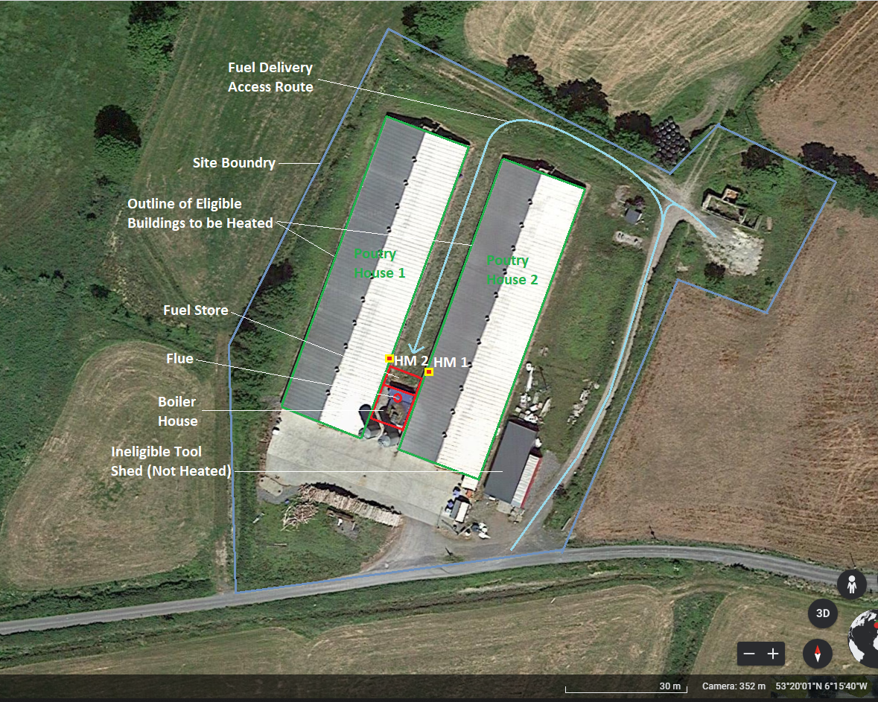
- A sample drawing and aerial image is shown below, and further guidelines are provided in the sample report.
Site Map SSRH Ref 50XXX 08/09/21 Version 1.0
Drawn by Jon Doe

- A schematic (block diagram) showing the proposed heating system
- Outline of each building (or process) to be heated
- Any existing boilers retained and clearly identified as top up and / or back-up heating systems
- The proposed new renewable heat boilers, noting their size and fuel type
- Any proposed headers, buffer tanks, thermal stores and heat exchangers
- Proposed points of connection between the new and existing elements
- Location of the proposed heat meters
- All heating circuits including flow and return directions
- A sample schematic is shown below, and further guidelines are provided in the sample report.

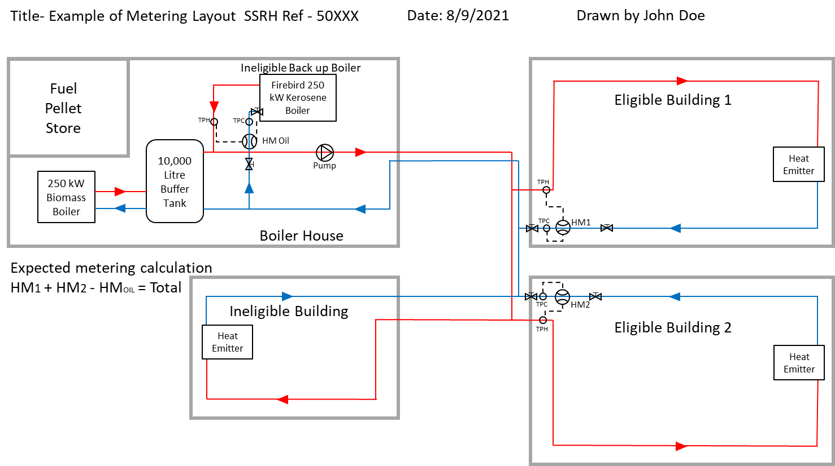

Appendix A4 Boiler specifications and Eco-Design requirements

- For Biomass Boilers (≤ 500 kW)

- Declaration of Conformity issued by the boiler manufacturer as outlined in the specific regulated measure i.e., Regulation 2015/1189.
- ‘Table 1’ product information, as outlined in Annex II of Regulation 2015/1189, specifically the following:
- useful heat output (P) {useful heat output’ or ‘P’ means the heat output of a solid fuel boiler transmitted to the heat carrier, expressed in kW}
- seasonal space heating energy efficiency (ɳ_{s})
- seasonal space heating emissions {Dust (particulate matter, PM) < 40 mg/Nm3; NOx<200 mg/Nm3 & CO < 500 mg/Nm3 & OGCs<20 mg/Nm3}

- Biomass Boilers (500kW – 1MW)

For SSRH, all the requirements as per ‘Table 1’ product information, as outlined in Annex II of Regulation 2015/1189 also apply.
This requirement is greater than the current legal requirements contained in the Eco-design regulations.
In all cases, emission measurements shall be conducted by an ISO 17025 accredited air monitoring contractor.

